
Generative Models vs Traditional AI-Driven Anomaly Detection in Large-Scale System Logs – A Comparative Study
Thesis Report

June 20, 2026
Fall 2024 Air University
Muhammad Asad Mahmood Khan Roll # 243260 MSAI-4

Abstract
The increasing complexity of distributed systems such as Hadoop (HDFS), Spark, and OpenStack has rendered manual log monitoring obsolete. This research proposes a comprehensive comparative study evaluating Traditional Machine Learning (ML), Deep Learning (DL), and Generative AI models for the automated detection of system anomalies within large-scale log collections. Initial benchmarking reveals that traditional supervised algorithms achieve high precision on structured data but rely heavily on labor-intensive manual feature engineering and demonstrate poor adaptability when applied to different system architectures. Furthermore, traditional unsupervised methods like Isolation Forest have shown significantly lower efficacy, highlighting a critical gap in detecting unknown errors. The primary objective of this thesis is to transcend these limitations by validating Generative Deep Learning architectures. This study aims to prove that Generative AI provides a superior balance of automation and accuracy, capable of maintaining robust performance across heterogeneous environments without the extensive manual feature engineering required by traditional ML approaches.

Chapter 1: Introduction
1.1 Background
System logs serve as the primary source of truth for diagnosing failures in cloud infrastructure. In distributed environments, a single user request triggers execution traces across thousands of nodes, generating massive volumes of unstructured data. As systems scale, the variety and volume of these logs make manual rule-based detection impossible.
1.2 Problem Statement
Current industry standards for log analysis face a functional dichotomy:
- Brittleness of Supervised ML: Traditional models like SVM and XGBoost offer high accuracy but are fundamentally brittle. They require rigid, manual feature extraction that fails catastrophically when log syntax changes or when deployed across diverse systems.
- Inefficacy of Unsupervised Baselines: Unsupervised methods struggle to capture complex sequential dependencies, resulting in poor detection rates for unknown error patterns. There is a critical lack of a unified framework that combines the high accuracy of supervised learning with the flexibility of unsupervised discovery.
1.3 Objectives
This research aims to:
- Benchmark traditional supervised and unsupervised models on the HDFS, Hadoop and Spark datasets to establish a baseline for known error detection.
- Evaluate discriminative Deep Learning (DL) sequence models for anomaly detection without manual feature extraction.
- Validate Generative AI architectures to determine their superiority in detecting unknown anomalies and their performance consistency across distinct platform datasets.
- Conduct a tri-fold comparative study producing a definitive performance matrix comparing ML, DL, and Generative AI.
1.4 Research Questions
RQ1: To what extent can Generative AI architectures maintain consistent anomaly detection performance across distinct, heterogeneous distributed systems (e.g., evaluated independently on HDFS and Spark) compared to Traditional Supervised models?
RQ2: Can Generative Deep Learning models eliminate the dependency on manual feature engineering required by traditional AI, while maintaining high F1-scores?
RQ3: Can deep generative models significantly outperform traditional unsupervised baselines in detecting unknown 'zero-day' anomaly patterns?

Chapter 2: Literature Review
2.1 Phase I: Traditional Machine Learning
Foundational studies demonstrated that supervised methods like Decision Trees and SVMs can achieve high accuracy on structured logs. However, these approaches depend entirely on parsing logs into fixed templates and manually constructing Event Count Matrices. While accurate for specific datasets, they lack portability.
2.2 Phase II: Deep Learning Sequence Models
To reduce manual effort, approaches like DeepLog and LogRobust applied LSTMs to model logs as natural language sequences. These models achieved high F1-scores by learning sequential patterns, reducing the need for manual feature engineering but still often requiring task-specific tuning.
2.3 Phase III: Generative & Transformer Models
Recent advancements leverage Transformers and Generative Pre-training to understand the deep semantic context of logs. These models achieve near-perfect F1-scores on benchmarks but are computationally expensive.
2.4 Research Gap
Despite these advancements, a critical gap remains in evaluating consistent performance across distinct systems. Most existing studies benchmark models on a single dataset in isolation. There is limited comparative research that rigorously tests these models across multiple, separate system datasets (like HDFS, Spark, and OpenStack) to determine if Generative AI consistently outperforms Traditional ML across the board without relying on manual feature extraction.

Chapter 3: Methodology
This section outlines the five-phase comparative study methodology used to evaluate Traditional ML, Deep Learning, and Generative AI for log anomaly detection.
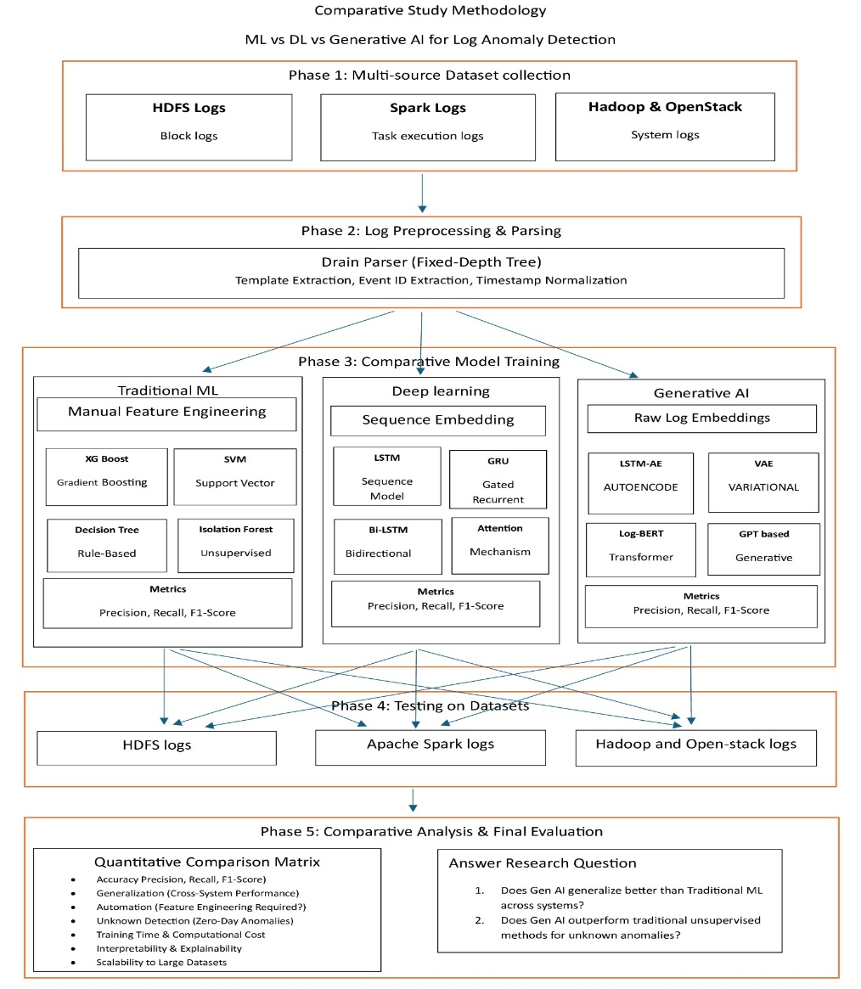
3.1 Phase 1: Multi-Source Dataset Collection
A multi-source repository is utilized to ensure rigorous comparative testing across heterogeneous environments.
- HDFS Logs: Collection of block logs.
- Apache Spark Logs: Collection of task execution logs.
- Hadoop & OpenStack: Collection of system logs.
3.2 Phase 2: Log Preprocessing & Parsing
Raw logs are processed using the Drain Parser, a Fixed-Depth Tree approach. The preprocessing involves template extraction, event ID extraction, and timestamp normalization.
3.3 Phase 3: Comparative Model Training
The study implements three parallel pipelines:
- Pipeline 1: Traditional ML: Relies on manual feature engineering. Models include Support Vector (SVM), Gradient Boosting (XGBoost), Rule-Based (Decision Tree), and Unsupervised (Isolation Forest).
- Pipeline 2: Deep Learning: Utilizes sequence embedding. Models incorporate Attention Mechanisms, Bidirectional Bi-LSTM, Gated Recurrent GRU, and Sequence Model LSTM.
- Pipeline 3: Generative AI: Leverages raw, self-supervised log embeddings. Models evaluated include GPT-based Generative, Log-BERT Transformer, Variational VAE, and LSTM-AE Autoencoder.
3.4 Phase 4: Cross-Platform Testing
To thoroughly assess model efficacy, each trained model is tested on the holdout test set (e.g., using an 80/20 train-test split) of its respective source dataset. This independent evaluation is conducted across the HDFS, Apache Spark, and Hadoop/OpenStack log collections to verify consistent performance across distinct system environments.
3.5 Phase 5: Comparative Analysis & Final Evaluation
Models are assessed using a Quantitative Comparison Matrix focusing on metrics such as Precision, Recall, and F1-Score. The evaluation also measures Performance Consistency (evaluation across individual system datasets), Automation (feature engineering requirements), Unknown Detection (zero-day anomalies), Training Time, Interpretability, and Scalability to large datasets. This matrix will directly answer the core research questions regarding Generative AI's capability to maintain high performance across systems and outperform traditional unsupervised methods.
Chapter 4: Results & Analysis
4.1 Baseline Performance (HDFS v1)
This section documents the initial benchmarking phase of the traditional supervised machine learning pipeline. Models were evaluated using a strict 80% training and 20% testing split on the HDFS log dataset. The dataset presents a severe class imbalance challenge, comprising 558,223 normal log vectors and 16,838 anomaly vectors. The 20% holdout test set contains a total of 115,013 instances, with 111,645 normal cases and 3,368 anomalies.
To address the severe class distribution disparity during training, the XGBoost classifier incorporated an automated minority class weighting adjustment via the scale_pos_weight parameter.
4.1.1 Quantitative Performance Metrics
This section documents the comprehensive benchmarking phase evaluating Traditional Machine Learning, Deep Learning, and Generative AI pipelines. Models were evaluated using a strict 80% training and 20% testing split on the HDFS log dataset. The dataset presents a severe class imbalance challenge, comprising 558,223 normal log vectors and 16,838 anomaly vectors. The 20% holdout test set contains a total of 115,013 instances, with 111,645 normal cases and 3,368 anomalies.
To address the severe class distribution disparity during training, algorithms like the XGBoost classifier incorporated automated minority class weighting adjustments.
4.1.1 Traditional Machine Learning Results
In this phase, XGBoost and Support Vector Machine (SVM) were applied to detect anomalies in HDFS log data using manually engineered event count features.
- XGBoost: Achieved near-perfect performance, with an anomaly precision of 0.9985, recall of 0.9997, and F1-score of 0.9991. The model made only 5 false positive errors and missed just 1 anomaly out of 3,368 in the test set.
- SVM: Demonstrated strong baseline performance, achieving an anomaly precision of 0.9634, recall of 0.9994, and F1-score of 0.9811. However, it produced 128 false positives and missed 2 anomalies.
XGBoost distinctly outperformed SVM across all key parameters, highlighting its superior capacity to construct non-linear decision boundaries across complex event distributions.

Xgboost Results
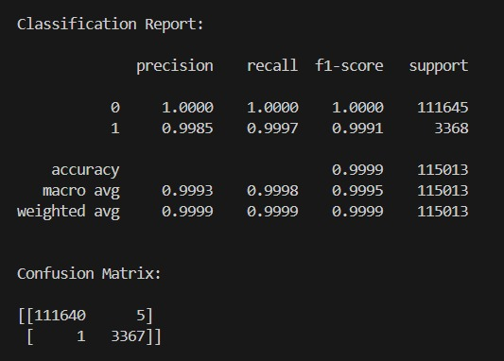
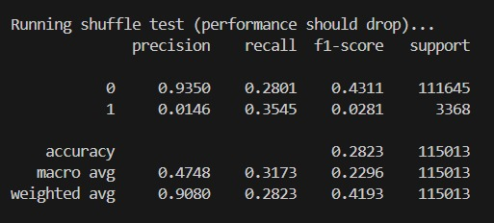
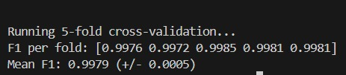
SVM
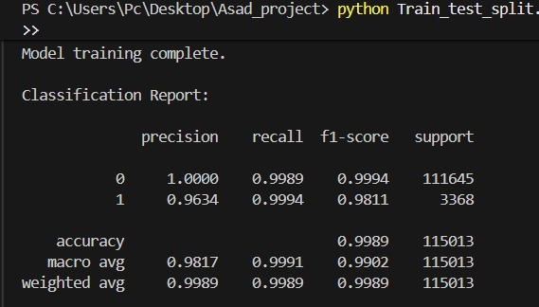
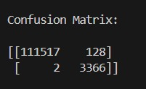
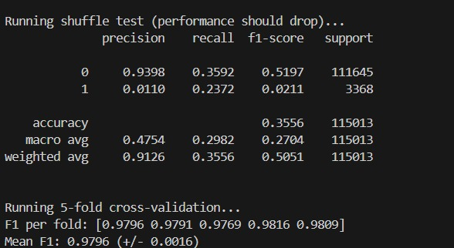
4.1.2 Deep Learning (Supervised) Results
The supervised Deep Learning pipeline evaluated sequence models capable of learning from log data without the rigid manual feature engineering required by traditional ML.
- LSTM: The Long Short-Term Memory network achieved an anomaly precision of 0.9808, a recall of 0.9988, and an F1-score of 0.9897. The model produced 66 false positives and missed 4 anomalies, while maintaining a perfect ROC-AUC of 1.0.
- GRU: The Gated Recurrent Unit performed comparably to the LSTM, achieving a precision of 0.9808, a recall of 0.9991, and an F1-score of 0.9899. It also produced 66 false positives but missed only 3 anomalies, similarly achieving an ROC-AUC of 1.0.
LSTM
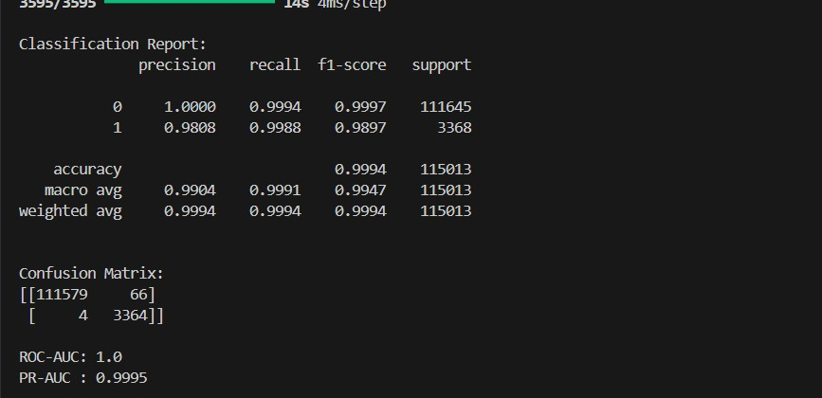
GRU
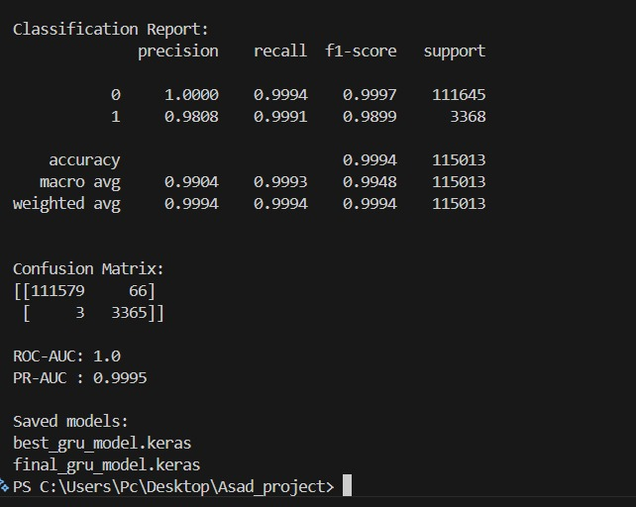
4.1.3 Generative AI Results
The Generative AI models were trained exclusively on normal data sequences (normal-only), evaluating their capability to reconstruct logs and detect anomalies through reconstruction errors without relying on supervised anomaly labels.
- LSTM Autoencoder: Achieved an anomaly precision of 0.7232, a recall of 0.8818, and an F1-score of 0.7946. The model resulted in 1,137 false positives and 398 missed anomalies, with an ROC-AUC of 0.9964 and PR-AUC of 0.9049.
- LSTM-VAE: The Variational Autoencoder yielded an anomaly precision of 0.6944, a recall of 0.7429, and an F1-score of 0.7178. It generated 1,101 false positives and 866 missed anomalies, achieving an ROC-AUC of 0.9876 and PR-AUC of 0.7854.
LSTM auto encoder
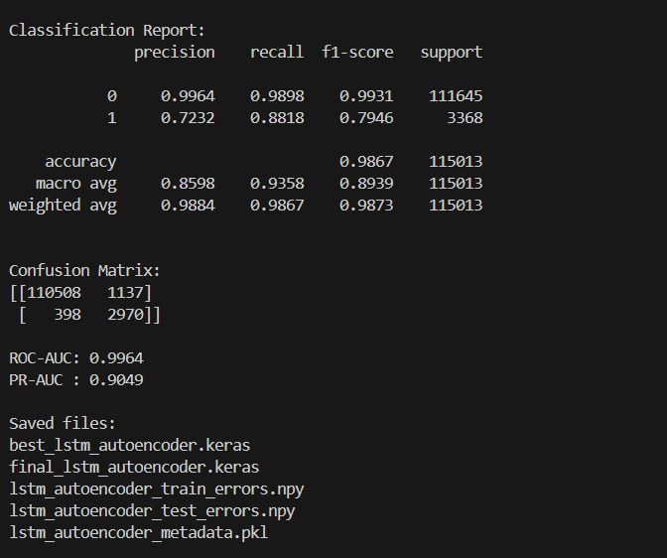
LSTM VAE
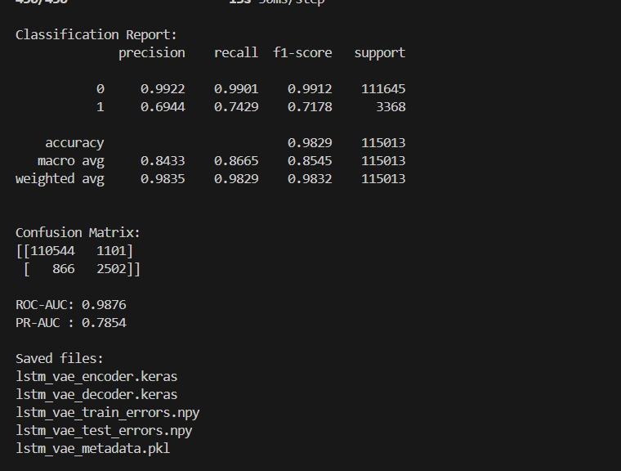
4.1.5 Comparative Analysis Synthesis
The benchmarking results present a clear trade-off between absolute accuracy and functional autonomy. While traditional supervised models like XGBoost achieve near-perfect F1-scores, they rely entirely on labeled training data and manual feature engineering (Event Count Matrices).
The supervised Deep Learning sequence models (LSTM and GRU) successfully matched this high accuracy (F1-scores of ~0.99) while eliminating the need for rigid manual feature extraction, proving their efficacy at understanding sequential log patterns.
Conversely, the Generative AI models (LSTM Autoencoder and VAE) exhibit lower raw precision and recall metrics. However, these architectures operate under a fundamentally different, strictly unsupervised paradigm. Because they are trained exclusively on normal system behavior, their F1-scores (~0.71 - 0.79) represent a baseline capability for discovering unknown, zero-day anomalies without prior exposure to specific failure states. The high ROC-AUC scores for both generative models (>0.98) indicate that despite the lower precision thresholds, the underlying continuous reconstruction error distributions are highly separable.

Model | Type | Anomaly Precision | Anomaly Recall | Anomaly F1 | ROC-AUC | PR-AUC
XGBoost | Traditional ML | 99.85% | 99.97% | 99.91% | - | -
SVM | Traditional ML | 96.34% | 99.94% | 98.11% | - | -
LSTM | Supervised DL | 98.08% | 99.88% | 98.97% | 100.00% | 99.95%
GRU | Supervised DL | 98.08% | 99.91% | 98.99% | 100.00% | 99.95%
LSTM Autoencoder | Generative / Normal-only | 72.32% | 88.18% | 79.46% | 99.64% | 90.49%
LSTM-VAE | Generative / Normal-only | 69.44% | 74.29% | 71.78% | 98.76% | 78.54%

